## Day 1 : Python Basics

## Manish Beesetti

|  |  |
| --- | --- |
| Topic | Page number |
| seting up python |  |
| Native data types |  |
| comprehension |  |
| strings |  |
| Regular expressions |  |

SETTING UP PYTHON ENVIRONMENT

There are multiple ways to get a working python distribution, but I would suggest to use anaconda as it is powerfull and contains numerous packages which are pre-installed. So lets get started.

Ananconda : <https://www.anaconda.com/>



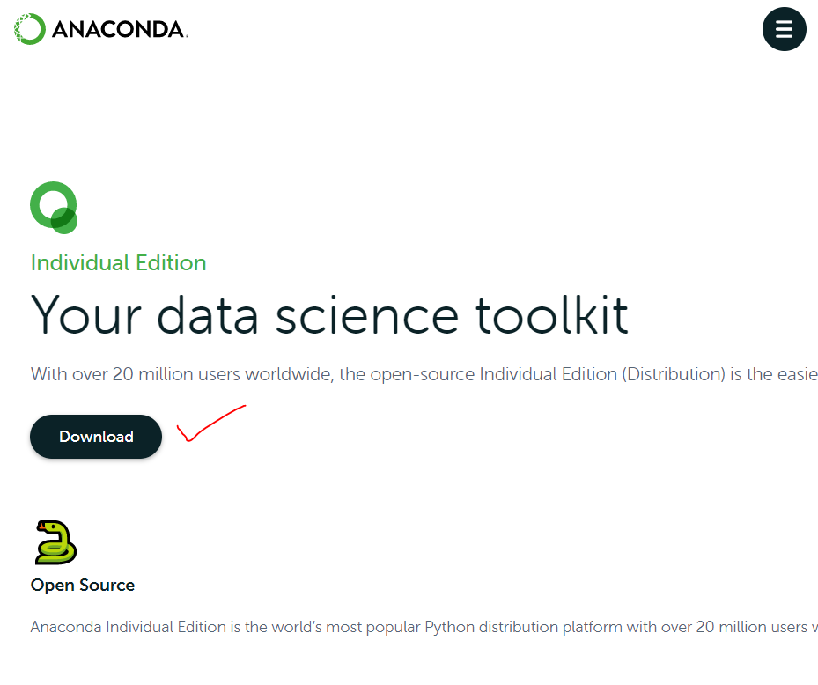

Choose the distribution according to your LOCAL MACHINE and its Architecture.

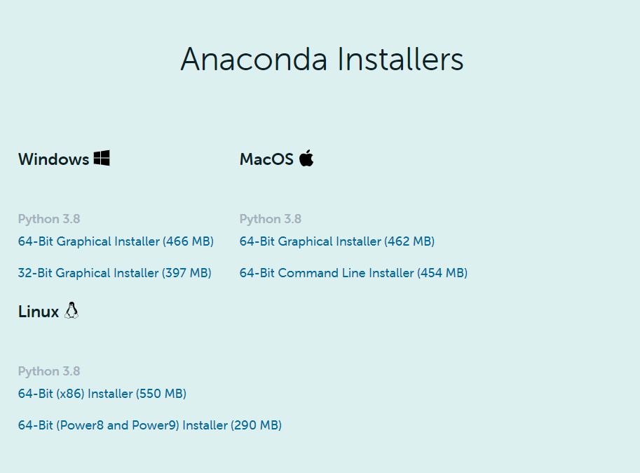

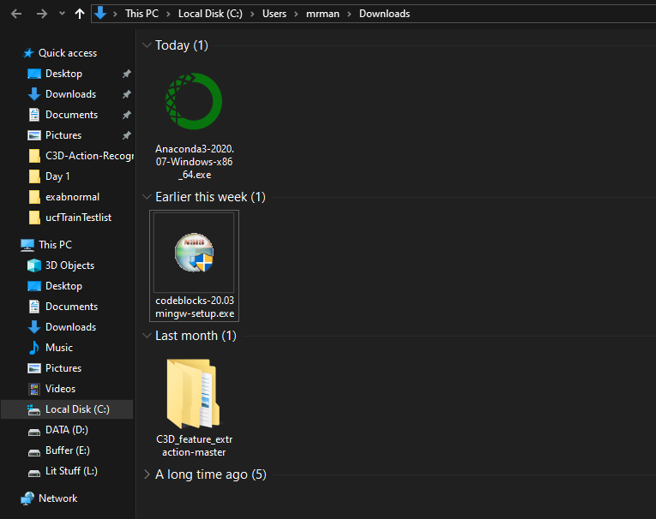

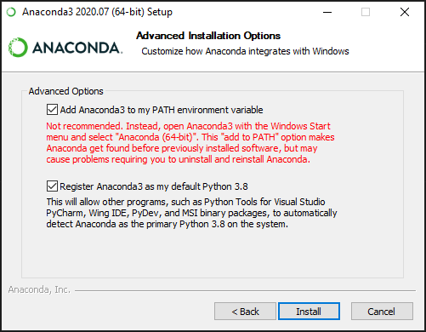

TO check if everything is properly installed open command prompt and type the following commands.

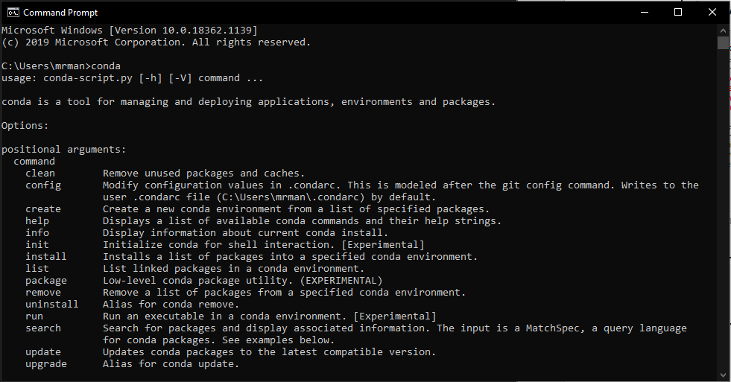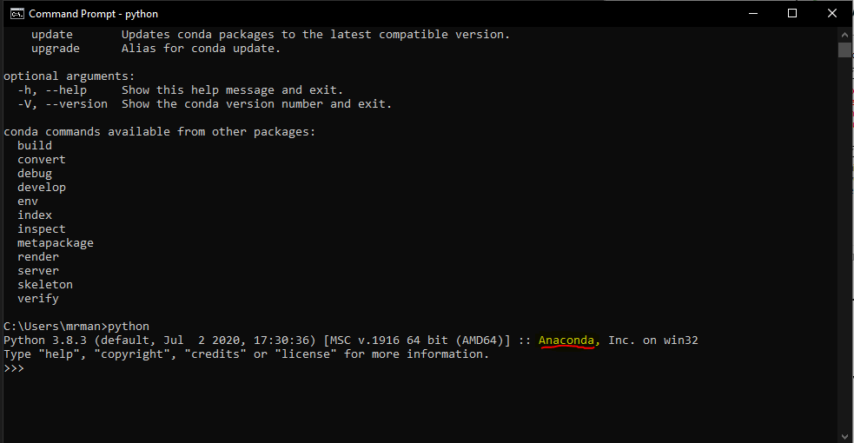

Since we are done setting up Anaconda python , now lets set up a text editor, you can choose any text editor I’ll be using atom text editor.

Lets setup Atom text editor.

Atom Text Editor : <https://atom.io/>

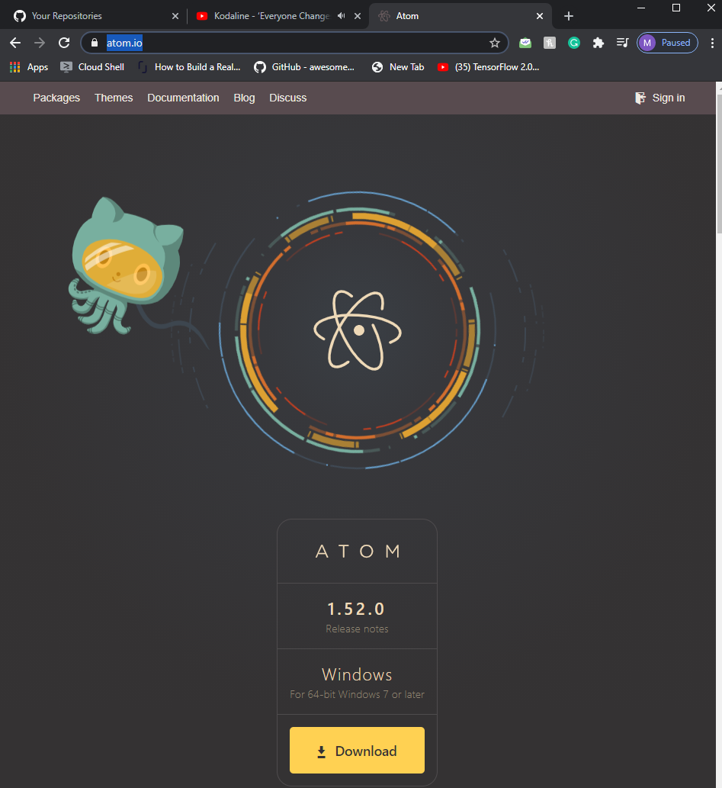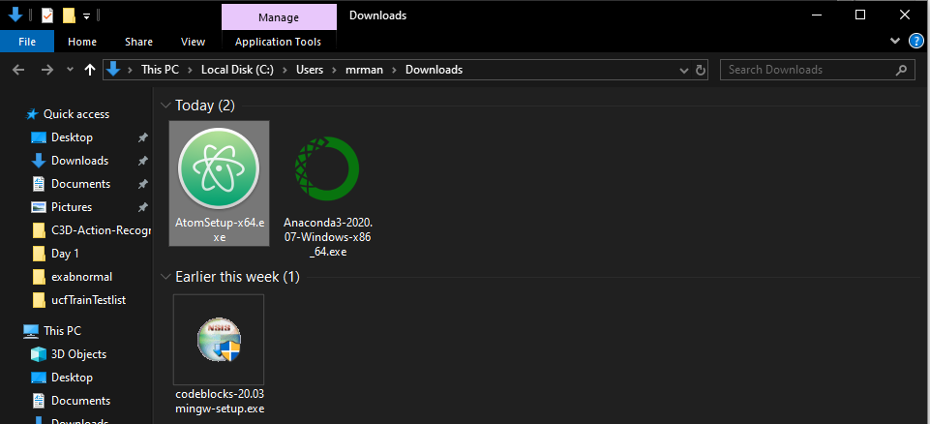

Once the installlation is done you’ll be seeing the welcome screen of atom Text Editor.

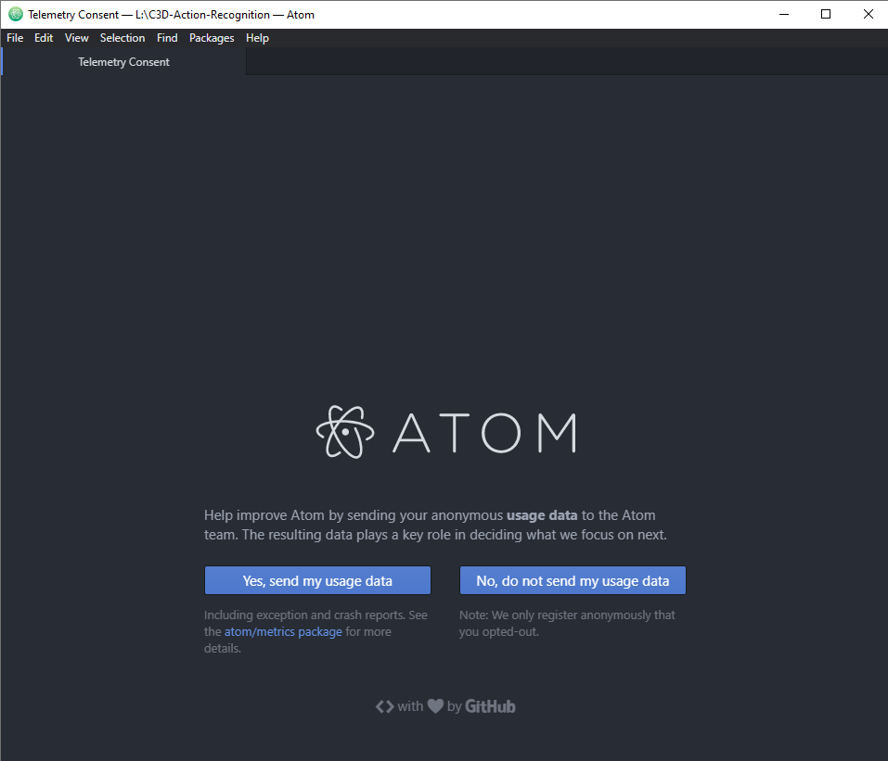

Now let’s setup python auto run to ease the process of execution.

**File > settings > install > search packlages > atom-python-run > install**

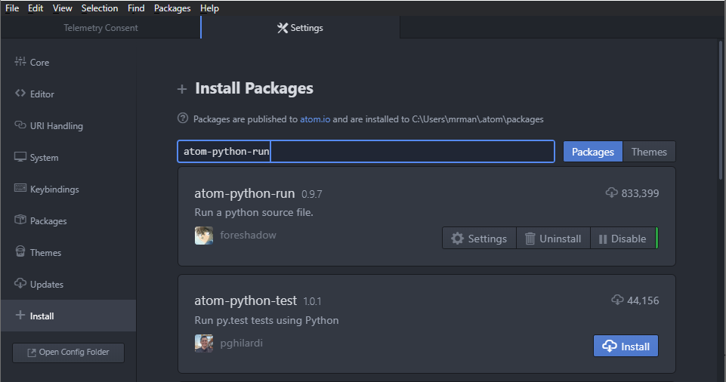

The only reason I am using this package is to save time to execute. (TBH Lazyy)

You can just simply press f5 or f6 to execute the script on your atom window.

**Finally Python.**

**Native Datatypes**

|  |  |
| --- | --- |
| Text Type: | str |
| Numeric Types: | int, float, complex |
| Sequence Types: | list, tuple, range |
| Mapping Type: | dict |
| Set Types: | set, frozenset |
| Boolean Type: | bool |
| Binary Types: | bytes, bytearray, memoryview |

**Strings :**

**Note :** Python does not have a character data type, a single character is simply a string with a length of 1. Cause it doesnot have char datatype.

Now check out the .py file in the directory.